A
Project Based Learning Report
On

CROP GUIDANCE SYSTEM
Submitted to CMREC, HYDERABAD
In Partial Fulfillment of the requirements for the Award of Degree of
BACHELOR OF TECHNOLOGY IN
COMPUTER SCIENCE AND ENGINEERING (DATA SCIENCE)

Submitted By
M. MUKUNDA SAI (238R1A6744)
B. PUJITHA (238R1A6711)
V. BHARATH (238R1A6760)
C. ASHOK (248R1A6704)

Under the Esteemed guidance of

Mrs. P. SANDHYA REDDY
Assistant Professor, Department of CSE (Data Science)


Department of Computer Science & Engineering (Data Science) CMR ENGINEERING COLLEGE
UGC AUTONOMOUS
(Approved by AICTE, NEW DELHI, Affiliated to JNTU, Hyderabad) Kandlakoya, Medchal Road, R.R. Dist. Hyderabad-501 401.
2024-2025

I

CMR ENGINEERING COLLEGE
UGC AUTONOMOUS
(Accredited by NBA,Approved by AICTE NEW DELHI, Affiliated to JNTU, Hyderabad) Kandlakoya, Medchal Road, Hyderabad-501 401

Department of Computer Science &Engineering (Data Science)

CERTIFICATE

This is to certify that the project entitled “COMPARATIVE ANALYSIS OF DEEP LEARNING AND STATISTICAL MODELS FOR AIR POLLUTANTS PREDICTION
IN URBAN AREAS” is a bonafide work carried out by

M. MUKUNDA SAI (238R1A6744)
B. PUJITHA (238R1A6711)
V. BHARATH (238R1A6760)
C. ASHOK (248R1A6704)

in partial fulfillment of the requirement for the award of the degree of BACHELOR OF TECHNOLOGY in COMPUTER SCIENCE AND ENGINEERING (DATA SCIENCE)
from CMR Engineering College, affiliated to JNTU, Hyderabad, under our guidance and supervision.

The results presented in this Major project have been verified and are found to be satisfactory.

Internal Guide Head of the Department

Mrs. P. SANDHYA REDDY
Dr. M. Laxmaiah

Assistant Professor Professor & H.O.D

CSE (Data Science), CMREC
CSE (Data Science), CMREC

II

DECLARATION

This is to certify that the work reported in the present Major project entitled “CROP GUIDANCE SYSTEM” is a record of bonafide work done by us in the Department of Computer Science and Engineering (Data Science), CMR Engineering College, JNTU Hyderabad. The reports are based on the project work done entirely by us and not copied from any other source. We submit our project for further development by any interested students who share similar interests to improve the project in the future.
The results embodied in this Major project report have not been submitted to any other University or Institute for the award of any degree or diploma to the best of our knowledge and belief.

M. MUKUNDA SAI (238R1A6744)
B. PUJITHA (238R1A6711)
V. BHARATH (238R1A6760)
C. ASHOK (248R1A6704)

III

ACKNOWLEDGMENT

We are extremely grateful to Dr. A. Srinivasula Reddy, Principal and Dr. M. Laxmaiah, HOD, Department of CSE (Data Science), CMR Engineering College for their constant support.

We are extremely thankful to Mrs. M. S. S. Lakshmi Lavanya, Assistant Professor, Internal Guide, Department of CSE(DS), for her constant guidance, encouragement and moral support throughout the project.

We will be failing in duty if We do not acknowledge with grateful thanks to the authors of the references and other literatures referred in this Project.

We express my thanks to all staff members and friends for all the help and co-ordination extended in bringing out this project successfully in time.

Finally, we are very much thankful to our parents who guided me for every step.

M. MUKUNDA SAI (238R1A6744)
B. PUJITHA (238R1A6711)
V. BHARATH (238R1A6760)
C. ASHOK (248R1A6704)

IV

ABSTRACT

This project addresses the global challenge of optimizing agricultural productivity through the implementation of a precise Crop Guidance System. The goal is to move beyond traditional, heuristic farming by applying an advanced Machine Learning Classification approach to predict the single most suitable crop label based on site-specific environmental and soil conditions. The model analyzes seven critical input features: Nitrogen (N), Phosphorus (P), Potassium (K) ratios, ambient Temperature, relative Humidity, soil pH level, and localized Rainfall. The core predictive capability is delivered by an ensemble method, the Random Forest Classifier (RFC), which is trained and deployed via a comprehensive Python-based stack. The system incorporates a Flask- based web interface for accessibility and secure user authentication using Sqlite3. For performance evaluation, the system utilizes robust classification metrics—Accuracy, Precision, Recall, and F1- Score —to guarantee model reliability. Empirical results demonstrate the RFC model's superior effectiveness in handling heterogeneous agricultural data, providing high-accuracy recommendations that offer actionable guidance crucial for sustainable and profitable agricultural planning.

V

 | CONTENTS
TOPIC |  | PAGE NO
ABSTRACT |  | V
LIST OF FIGURES |  | VIII
LIST OF SCREENSHOTS LIST OF TABLES |  | XI
1. INTRODUCTION |  | 1
2. LITERATURE SURVEY |  | 3
3. EXISTING SYSTEM |  | 5
  - Overview of Existing Crop Prediction Models
  - Drawbacks of Existing system
- PROPOSED SYSTEM 6
  - A Deep Learning Approach for Crop Prediction
  - Advantages of Proposed system
- UML DIAGRAMS 7
  - Use Case Diagram
  - Class Diagram
  - Activity Diagram
  - Sequence Diagram
- SOFTWARE ENVIRONMENT 15
  - Deep Learning
  - Deep Learning vs Machine Learning
  - How Deep Learning Works
  - Deep Learning Applications
  - Deep Learning Hardware Requirements
  - Python Language
  - Features in Python
  - Libraries/Packages

- SYSTEM REQUIREMENTS SPECIFICATIONS 24
  - Software Requirements
  - Hardware Requirements

VI

- FUNCTIONAL REQUIREMENTS 27
  - Output Design and Definition
  - Input Design, Stages, Types, Media
  - User Interface Design
  - Performance Requirements
- SOURCE CODE 32
- RESULTS AND DISCUSSION 40
  - Implementation description
  - Dataset Description
  - Model D
- CONCLUSION AND FUTURE SCOPE 49
- REFERENCES 50

VII

LIST OF FIGURES

FIG.NO | DESCRIPTION | PAGENO
5.1.1 | Use Case Diagram | 8
5.2.1 | Class Diagram | 9
5.3.1 | Activity Diagram | 10
5.4.1 | Sequence Diagram | 11

VIII

CHAPTER 1 INTRODUCTION

Overview

Over the past few years, the need for increased agricultural productivity to meet global food demand has become a major challenge, particularly when coupled with increasing climate variability. This necessity mandates a transition toward precision agriculture.¹ Data science applications, specifically those leveraging predictive modeling, are critical for optimizing resource inputs—such as fertilizer and water—and maximizing yield per unit area. This project defines the crop selection challenge as a classification problem: classifying a set of site-specific environmental measurements into a discrete, optimal crop label.¹ The model provides a definitive recommendation, such as "Grow Wheat" or "Grow Rice," thereby simplifying the decision- making process for the agricultural stakeholder.

Research Motivation
Traditional farming practices, often relying on historical norms, generalized climate data, or local expert knowledge, frequently lead to suboptimal crop choices. This results in significant economic losses for farmers and contributes to excessive resource consumption, particularly water and chemical fertilizers, challenging sustainability goals. The primary goal of this research is to minimize this uncertainty through data-driven recommendations that mitigate the risk of failure. The application of predictive modeling offers a direct solution to the silent economic erosion caused by inefficient planning.
The challenge is exacerbated by the highly complex, non-linear interactions among the determining factors: nutrient levels (Nitrogen, Phosphorus, Potassium), meteorological conditions (Temperature, Humidity), and soil chemistry (pH). Simple linear or statistical models often fail to capture these intricate, synergistic relationships. The inherent data heterogeneity— where input features span vastly different scales (e.g., pH on a 0–14 scale versus Rainfall in millimeters or NPK ratios in parts per million)—requires robust preprocessing techniques and advanced ML architectures. Recent advancements in Deep Learning and high-performance ensemble methods, such as the Random Forest Classifier, provide the necessary tools to handle this high-dimensional, heterogeneous feature data, justifying the selection of this methodology for efficient and accurate prediction.

Problem Statement
Achieving sustainable output maximization is a critical challenge in agriculture. Given the complex, non-linear relationship between seven critical environmental and soil parameters—N, P, K, Temperature, Humidity, pH, and Rainfall —the central technical challenge is to design a robust predictive model that accurately classifies and recommends the optimal crop for a given location to ensure maximal resource efficiency and profitability.
To address this, the research aims to develop, implement, and rigorously evaluate the performance of the Random Forest Classifier. This involves providing detailed architectural insights into the necessary preprocessing steps (feature scaling and label encoding) and outlining the architectural deployment required for a functional, real-world Crop Guidance System. The resultant system is designed to contribute actionable prescriptions, fundamentally shifting the farm management paradigm from observation and estimation to data-driven prescription.

CHAPTER 2 LITERATURE SURVEY

Literature Survey 1:

Title: "Technological Advancements in Automated Guidance Systems” Author: Lowenberg-Debor, J Erickson, Olsen H.J.,
Abstract: Examines research on computer vision systems that use cameras and image processing (often with deep learning/AI) to detect crop rows, furrow boundaries, and plant spacing. This includes the use of LiDAR, ultrasonic, and other proximity sensors for steering corrections in real-time, especially in fields where GNSS signals may be obstructed or in early crop stages where plants are small.

Literature Survey 2:

Title: "Crop Recommendation and Decision Support System" Author: Dighe, D. Joshi Padhy, N.M Ray.,
Abstract: Surveys studies that guide the precise application of inputs (fertilizers, water, pesticides) by creating prescription maps. The guidance system directs machinery to adjust application rates based on the real-time needs of specific zones within a field (site-specific management). Modern crop recommendation systems are evolving from simple fixed rules to data-driven, predictive models that leverage big data analytics and AI to provide dynamic, site-specific guidance, thus optimizing resource use and improving yield efficiency.

Literature Survey 3:

Title: "Impact, and Sustainability of Crop Guidance System" Author: Abdellatif Bekkar; Badr Hssina et.al.,
Abstract: While the technical and agronomic benefits of crop guidance systems are well- established, widespread global adoption is constrained by economic viability and a digital divide. Future guidance strategies must prioritize user-friendly interfaces, lower-cost solutions.

CHAPTER 3 EXISTING MODEL

Overview of Existing Crop Prediction Models

Traditional crop planning often relies on subjective methods, including seasonal records, broad regional climate averages, and non-quantitative visual or textural assessments of soil quality. Early attempts at quantitative guidance used simpler statistical methods, such as regression analysis, which might correlate historical yield figures with one or two dominant factors like average rainfall or nitrogen levels. These approaches are foundational but provide only limited insight into the complex system dynamics.Furthermore, traditional guidance often employs subjective or undefined evaluation criteria, leading to a lack of confidence in the recommendation. Such systems lack the rigorous, quantitative metrics (such as Accuracy, Precision, and F1-Score) necessary to guarantee reliability and consistency. If the existing system relies on simple regression to predict yield, it offers a quantitative score but no direct, actionable classification. The user still faces the challenge of interpreting a vague yield score and translating it into a definitive decision ("Should I grow crop A or B?"). The proposed system’s advantage lies in its direct classification capability, which overcomes this ambiguity

Drawbacks of Existing system
The primary limitation of traditional or rudimentary statistical methods is their inherent inability to adequately model the complex, non-linear synergy between the seven critical input features (N, P, K, Temperature, Humidity, pH, Rainfall). These multi-factor interactions are crucial to determining crop suitability, and ignoring them results in significant predictive inaccuracy.
Finally, relying on domain experts for every planning decision is not scalable; as farm operations grow in complexity and geographical spread, expert judgment becomes a significant bottleneck. Traditional guidance lacks the mechanism to adapt quickly to highly specific soil or microclimate data, often relying on broad regional averages, contrasting sharply with the consistent, instantaneous, and scalable decision-making offered by a machine learning system.

CHAPTER 4 PROPOSED METHODOLOGY

A Machine Learning Approach for Crop Prediction

The proposed system utilizes a supervised Machine Learning methodology centered on classification. The Random Forest Classifier (RFC) is the chosen model due to its established capability to handle non-linear decision boundaries, mitigate the risk of overfitting through aggregation (bagging), and deliver high accuracy in classification tasks involving heterogeneous features. The system's input is defined by seven essential parameters: the soil nutrient ratios of Nitrogen (N), Phosphorus (P), and Potassium (K); environmental variables including Temperature, relative Humidity, and localized Rainfall; and the soil chemistry factor, pH.¹ This set of features necessitates a robust model that can process complex, interacting variables simultaneously. The selection of RFC provides a superior solution for static classification compared to models designed for sequential data (like LSTM and GRU ¹), as the agricultural challenge here requires a quick, condition-based classification rather than forecasting future temporal states.

Advantages of Proposed system

The Random Forest methodology provides several key advantages. It offers high generalization capabilities because it utilizes bootstrapping and aggregation (bagging) to construct multiple independent decision trees. This ensemble approach creates robust models that generalize effectively to unseen input conditions .The system utilizes evaluation metrics appropriate for the task. Although metrics used in time-series forecasting, such as Root Mean Square Error (RMSE), Mean Absolute Error (MAE), and {R}^{2} ¹, can be used as contextual benchmarks, the performance is fundamentally governed by Classification Optimized Metrics: Accuracy, Precision, Recall, and F1-Score.¹ The F1-Score is inherently superior for evaluating classification outputs because it measures the harmonic mean of Precision and Recall, providing a balanced assessment of performance across all crop classes

CHAPTER 5 UML DAIGRAMS
UML stands for Unified Modelling Language. UML is a standardized general-purpose modelling language in the field of object-oriented software engineering. The standard is managed, and was created by, the Object Management Group. The goal is for UML to become a common language for creating models of object-oriented computer software. In its current form UML is comprised of two major components: a Meta-model and a notation. In the future, some form of method or process may also be added to; or associated with, UML. The Unified Modelling Language is a standard language for specifying, Visualization, Constructing and documenting the artifacts of software system, as well as for business modelling and other non- software systems. The UML represents a collection of best engineering practices that have proven successful in the modelling of large and complex systems. The UML is a very important part of developing objects-oriented software and the software development process. The UML uses mostly graphical notations to express the design of software projects.

GOALS:

The Primary goals in the design of the UML are as follows:

    - Provide users a ready-to-use, expressive visual modelling Language so that they can develop and exchange meaningful models.
    - Provide extendibility and specialization mechanisms to extend the core concepts.
    - Be independent of programming languages and development process.
    - Provide a formal basis for understanding the modelling language.
    - Encourage the growth of OO tools market.
    - Support higher level development concepts such as collaborations, frameworks, patterns and components.
    - Integrate best practices.

Use Case Diagram

A use case diagram in the Unified Modelling Language (UML) is a type of behavioural diagram defined by and created from a Use-case analysis. Its purpose is to present a graphical overview of the functionality provided by a system in terms of actors, their goals (represented as use cases), and any dependencies between those use cases. The main purpose of a use case

diagram is to show what system functions are performed for which actor. Roles of the actors in the system can be depicted.

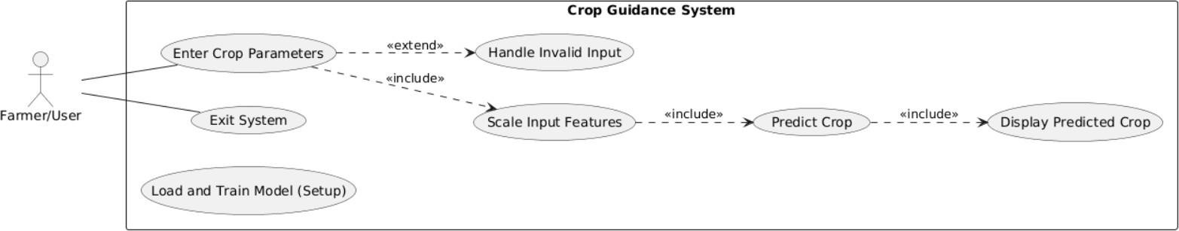

Fig5.1.1 Use Case Diagram

Class Diagram

The class diagram is used to refine the use case diagram and define a detailed design of the system. The class diagram classifies the actors defined in the use case diagram into a set of interrelated classes. The relationship or association between the classes can be either an "is-a" or "has-a" relationship. Each class in the class diagram may be capable of providing certain functionalities. These functionalities provided by the class are termed "methods" of the class. Apart from this, each class may have certain "attributes" that uniquely identify the class

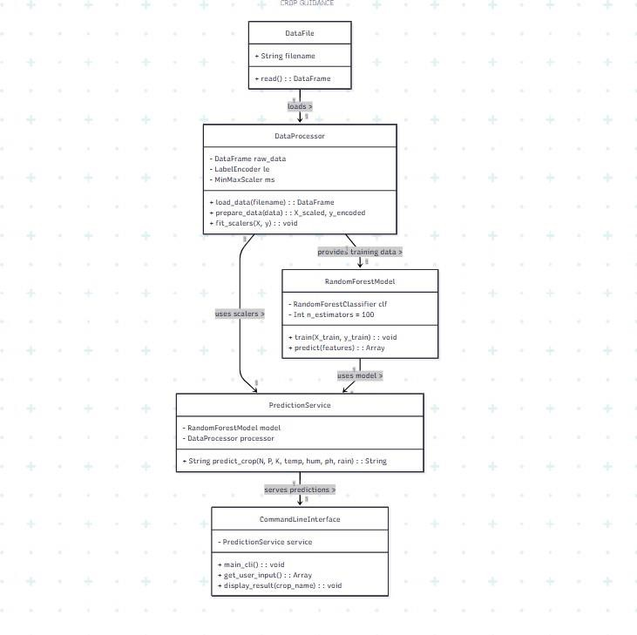

Fig5.2.1 Class Diagram

Activity Diagram

The process flows in the system are captured in the activity diagram. Like a state diagram, an activity diagram also consists of activities, actions, transitions, initial and final states, and guard conditions.
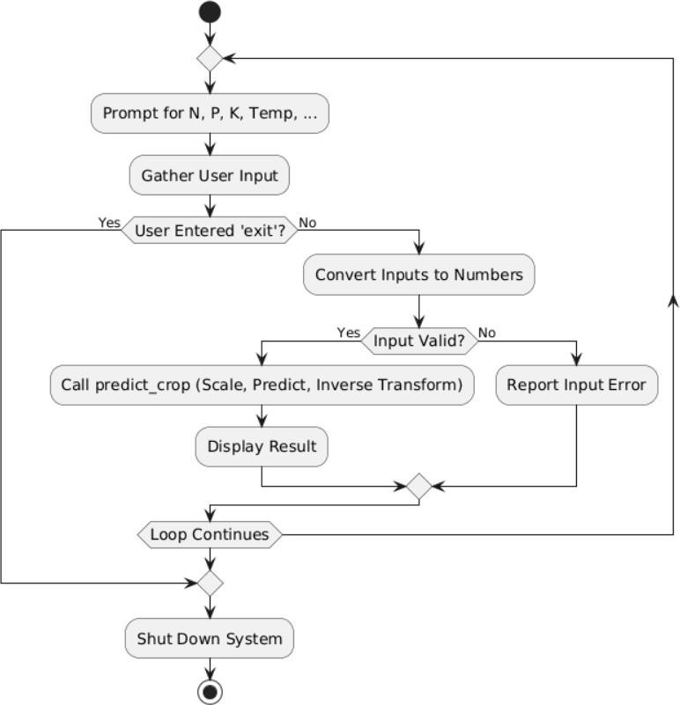

Fig5.3.1 Activity Diagram

Sequence Diagram

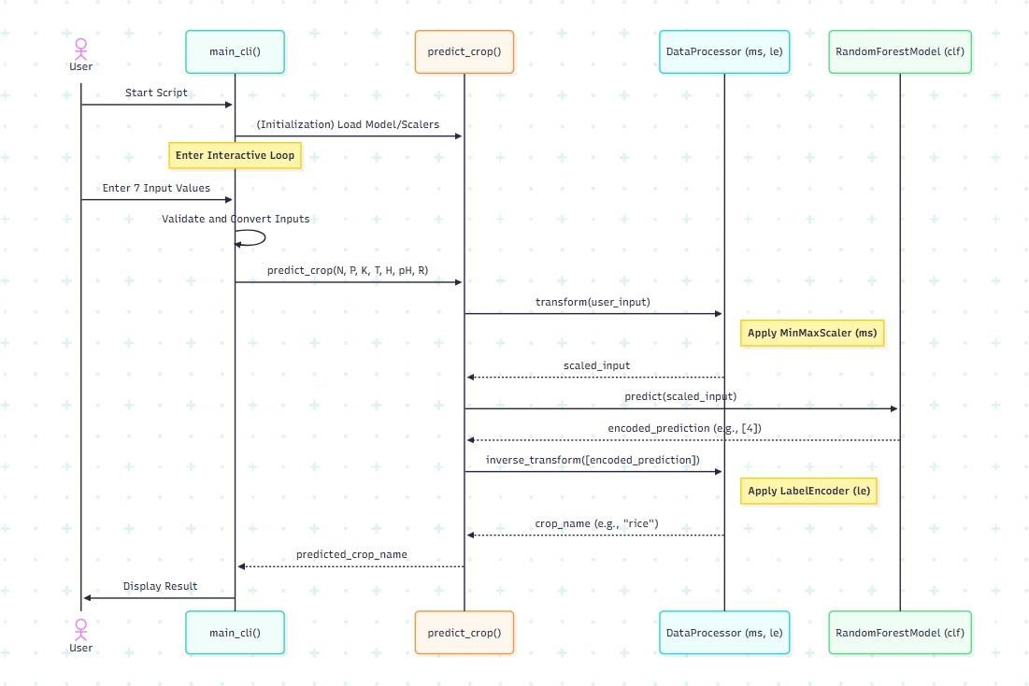
A sequence diagram represents the interaction between different objects in the system. The important aspect of a sequence diagram is that it is time-ordered. This means that the exact sequence of the interactions between the objects is represented step by step. Different objects in the sequence diagram interact with each other by passing "messages".

Fig5.4.1 Sequence Diagram

CHAPTER 6 SOFTWARE ENVIRONMENT

Deep Learning

What is deep learning?

Deep learning is a subset of machine learning, which is essentially a neural network with three or more layers. These neural networks attempt to simulate the behaviour of the human brain— albeit far from matching its ability—allowing it to “learn” from large amounts of data. While a neural network with a single layer can still make approximate predictions, additional hidden layers can help to optimize and refine for accuracy.
Deep learning drives many artificial intelligence (AI) applications and services that improve automation, performing analytical and physical tasks without human intervention. Deep learning technology lies behind everyday products and services (such as digital assistants, voice-enabled TV remotes, and credit card fraud detection) as well as emerging technologies (such as self-driving cars).

Deep Learning vs Machine Learning

If deep learning is a subset of machine learning, how do they differ? Deep learning distinguishes itself from classical machine learning by the type of data that it works with and the methods in which it learns.
Machine learning algorithms leverage structured, labelled data to make predictions— meaning that specific features are defined from the input data for the model and organized into tables. This doesn’t necessarily mean that it doesn’t use unstructured data; it just means that if it does, it generally goes through some pre-processing to organize it into a structured format.
Deep learning eliminates some of data pre-processing that is typically involved with machine learning. These algorithms can ingest and process unstructured data, like text and images, and it automates feature extraction, removing some of the dependency on human experts. For example, let’s say that we had a set of photos of different pets, and we wanted

to categorize by “cat”, “dog”, “hamster”, et cetera. Deep learning algorithms can determine which features (e.g. ears) are most important to distinguish each animal from another. In machine learning, this hierarchy of features is established manually by a human expert.
Then, through the processes of gradient descent and backpropagation, the deep learning algorithm adjusts and fits itself for accuracy, allowing it to make predictions about a new photo of an animal with increased precision.
Machine learning and deep learning models are capable of different types of learning as well, which are usually categorized as supervised learning, unsupervised learning, and reinforcement learning. Supervised learning utilizes labelled datasets to categorize or make predictions; this requires some kind of human intervention to label input data correctly. In contrast, unsupervised learning doesn’t require labelled datasets, and instead, it detects patterns in the data, clustering them by any distinguishing characteristics. Reinforcement learning is a process in which a model learns to become more accurate for performing an action in an environment based on feedback to maximize the reward.
For a deeper dive on the nuanced differences between the different technologies, see "AI vs. Machine Learning vs. Deep Learning vs. Neural Networks: What’s the Difference?"
For a closer look at the specific differences between supervised and unsupervised learning, see "Supervised vs. Unsupervised Learning: What's the Difference?"

How Deep Learning Works

Deep learning neural networks, or artificial neural networks, attempts to mimic the human brain through a combination of data inputs, weights, and bias. These elements work together to accurately recognize, classify, and describe objects within the data.
Deep neural networks consist of multiple layers of interconnected nodes, each building upon the previous layer to refine and optimize the prediction or categorization. This progression of computations through the network is called forward propagation. The input and output layers of a deep neural network are called visible layers. The input layer is where the deep learning model ingests the data for processing, and the output layer is where the final prediction or classification is made.

Another process called backpropagation uses algorithms, like gradient descent, to calculate errors in predictions and then adjusts the weights and biases of the function by moving backwards through the layers to train the model. Together, forward propagation and backpropagation allow a neural network to make predictions and correct for any errors accordingly. Over time, the algorithm becomes gradually more accurate.
The above describes the simplest type of deep neural network in the simplest terms. However, deep learning algorithms are incredibly complex, and there are different types of neural networks to address specific problems or datasets. For example
    - Convolutional neural networks (CNNs), used primarily in computer vision and image classification applications, can detect features and patterns within an image, enabling tasks, like object detection or recognition. In 2015, a CNN bested a human in an object recognition challenge for the first time.
    - Recurrent neural network (RNNs) are typically used in natural language and speech recognition applications as it leverages sequential or times series data.

Deep Learning Applications

Real-world deep learning applications are a part of our daily lives, but in most cases, they are so well-integrated into products and services that users are unaware of the complex data processing that is taking place in the background. Some of these examples include the following:
Law enforcement: Deep learning algorithms can analyze and learn from transactional data to identify dangerous patterns that indicate possible fraudulent or criminal activity. Speech recognition, computer vision, and other deep learning applications can improve the efficiency and effectiveness of investigative analysis by extracting patterns and evidence from sound and video recordings, images, and documents, which helps law enforcement analyse large amounts of data more quickly and accurately.
Financial services: Financial institutions regularly use predictive analytics to drive algorithmic trading of stocks, assess business risks for loan approvals, detect fraud, and help manage credit and investment portfolios for clients.

Customer service: Many organizations incorporate deep learning technology into their customer service processes. Chatbots—used in a variety of applications, services, and customer service portals—are a straightforward form of AI. Traditional chatbots use natural language and even visual recognition, commonly found in call centre-like menus. However, more sophisticated chatbot solutions attempt to determine, through learning, if there are multiple responses to ambiguous questions. Based on the responses it receives, the chatbot then tries to answer these questions directly or route the conversation to a human user.
Virtual assistants like Apple's Siri, Amazon Alexa, or Google Assistant extends the idea of a chatbot by enabling speech recognition functionality. This creates a new method to engage users in a personalized way.

Healthcare: The healthcare industry has benefited greatly from deep learning capabilities ever since the digitization of hospital records and images. Image recognition applications can support medical imaging specialists and radiologists, helping them analyse and assess more images in less time.

Deep Learning Hardware Requirements

Deep learning requires a tremendous amount of computing power. High performance graphical processing units (GPUs) are ideal because they can handle a large volume of calculations in multiple cores with copious memory available. However, managing multiple GPUs on-premises can create a large demand on internal resources and be incredibly costly to scale.

Python Language

Python is an interpreter, object-oriented, high-level programming language with dynamic semantics. Its high-level built in data structures, combined with dynamic typing and dynamic binding; make it very attractive for Rapid Application Development, as well as for use as a scripting or glue language to connect existing components together. Python's simple, easy to learn syntax emphasizes readability and therefore reduces the cost of program maintenance. Python supports modules and packages, which encourages program modularity and code reuse. The Python interpreter and the extensive standard library are available in source or binary form without charge for all major platforms and can be freely distributed. Often, programmers fall in love with Python because of the increased productivity it provides. Since there is no compilation step, the edit-test-debug cycle is incredibly fast. Debugging Python programs is easy: a bug or bad input will never cause a segmentation fault. Instead, when the interpreter discovers an error, it raises an exception. When the program doesn't catch the exception, the interpreter prints a stack trace. A source level debugger allows inspection of local and global variables, evaluation of arbitrary expressions, setting breakpoints, stepping through the code a line at a time, and so on. The debugger is written in Python itself, testifying to Python's introspective power. On the other hand, often the quickest way to debug a program is to add a few print statements to the source: the fast edit-test-debug cycle makes this simple approach very effective.
Python is a dynamic, high-level, free open source, and interpreted programming language. It supports object-oriented programming as well as procedural-oriented programming. In Python, we don’t need to declare the type of variable because it is a dynamically typed language. For example, x = 10 Here, x can be anything such as String, int, etc.

Features in Python

There are many features in Python, some of which are discussed below as follows:

Free and Open Source

Python language is freely available at the official website, and you can download it from the given download link below click on the Download.

Python keyword. Download Python Since it is open source, this means that source code is also available to the public. So, you can download it, use it as well as share it.

Easy to code

Python is a high-level programming language. Python is very easy to learn the language as compared to other languages like C, C#, JavaScript, Java, etc. It is very easy to code in the Python language and anybody can learn Python basics in a few hours or days. It is also a developer-friendly language.

Easy to Read

As you will see, learning Python is quite simple. As was already established, Python’s syntax is straightforward. The code block is defined by the indentations rather than by semicolons or brackets.

Object-Oriented Language

One of the key features of Python is Object-Oriented programming. Python supports object- oriented language and concepts of classes, object encapsulation, etc.

GUI Programming Support

Graphical User interfaces can be made using a module such as PyQt5, PyQt4, wxPython, or Tk in python. PyQt5 is the most popular option for creating graphical apps with Python.

High-Level Language

Python is a high-level language. When we write programs in Python, we do not need to remember the system architecture, nor do we need to manage the memory.

Extensible feature

Python is an Extensible language. We can write some Python code into C or C++ language and, we can compile that code in C/C++ language.

Easy to Debug

Excellent information for mistake tracing. You will be able to quickly identify and correct the majority of your program’s issues once you understand how to interpret Python’s error traces. Simply by glancing at the code, you can determine what it is designed to perform.

Python is a Portable language

Python language is also a portable language. For example, if we have Python code for windows and if we want to run this code on other platforms such as Linux, Unix, and Mac then we do not need to change it, we can run this code on any platform.

Python is an integrated language

Python is also an integrated language because we can easily integrate Python with other languages like C, C++, etc.

Interpreted Language

Python is an Interpreted Language because Python code is executed line by line at a time. like other languages C, C++, Java, etc. there is no need to compile Python code this makes it easier to debug our code. The source code of Python is converted into an immediate form called byte code.

Large Standard Library

Python has a large standard library that provides a rich set of modules and functions so you do not have to write your own code for every single thing. There are many libraries present in Python such as regular expressions, unit-testing, web browsers, etc.

Dynamically Typed Language

Python is a dynamically typed language. That means the type (for example- int, double, long, etc.) for a variable is decided at run time not in advance because of this feature we don’t need to specify the type of variable.

Frontend and backend development

With a new project py script, you can run and write Python codes in HTML with the help of some simple tags <py-script>, <py-env>, etc. This will help you do frontend development work in Python like JavaScript. Backend is the strong forte of Python it’s extensively used for this work cause of its frameworks like Django and Flask.

Allocating Memory Dynamically

In Python, the variable data type does not need to be specified. The memory is automatically allocated to a variable at runtime when it is given a value. Developers do not need to write int y = 18 if the integer value 15 is set to y. You may just type y=18.

Libraries/Packages

Tensor flow
Tensor Flow is a free and open-source software library for dataflow and differentiable programming across a range of tasks. It is a symbolic math library, and is also used for machine learning applications such as neural networks. It is used for both research and production at Google.
TensorFlow was developed by the Google Brain team for internal Google use. It was released under the Apache 2.0 open-source license on November 9, 2015.

Numpy
Numpy is a general-purpose array-processing package. It provides a high- performance multidimensional array object, and tools for working with these arrays.
It is the fundamental package for scientific computing with Python. It contains various features including these important ones:
- A powerful N-dimensional array object
- Sophisticated (broadcasting) functions
- Tools for integrating C/C++ and Fortran code
- Useful linear algebra, Fourier transform, and random number capabilities
Besides its obvious scientific uses, Numpy can also be used as an efficient multi-dimensional container of generic data. Arbitrary datatypes can be defined

using Numpy which allows Numpy to seamlessly and speedily integrate with a wide variety of databases.

Pandas

Pandas is an open-source Python Library providing high-performance data manipulation and analysis tool using its powerful data structures. Python was majorly used for data munging and preparation. It had very little contribution towards data analysis. Pandas solved this problem. Using Pandas, we can accomplish five typical steps in the processing and analysis of data, regardless of the origin of data load, prepare, manipulate, model, and analyze. Python with Pandas is used in a wide range of fields including academic and commercial domains including finance, economics, Statistics, analytics, etc.

Matplotlib

Matplotlib is a Python 2D plotting library which produces publication quality figures in a variety of hardcopy formats and interactive environments across platforms. Matplotlib can be used in Python scripts, the Python and IPython shells, the Jupyter Notebook, web application servers, and four graphical user interface toolkits. Matplotlib tries to make easy things easy and hard things possible. You can generate plots, histograms, power spectra, bar charts, error charts, scatter plots, etc., with just a few lines of code. For examples, see the sample plots and thumbnail gallery.
For simple plotting the pyplot module provides a MATLAB-like interface, particularly when combined with IPython. For the power user, you have full control of line styles, font properties, axes properties, etc, via an object- oriented interface or via a set of functions familiar to MATLAB users.

Scikit – learn

Scikit-learn provide a range of supervised and unsupervised learning algorithms via a consistent interface in Python. It is licensed under a permissive simplified BSD license and is distributed under many Linux distributions, encouraging academic and commercial use.

CHAPTER 7 SYSTEM REQUIREMENTS

Software Requirements

Software requirements deal with defining software resource requirements and prerequisites that need to be installed on a computer to provide optimal functioning of an application. These requirements or prerequisites are generally not included in the software installation package and need to be installed separately before the software is installed.
Platform – In computing, a platform describes some sort of framework, either in hardware or software, which allows software to run. Typical platforms include a computer’s architecture, operating system, or programming languages and their runtime libraries.
Operating system is one of the first requirements mentioned when defining system requirements (software). Software may not be compatible with different versions of same line of operating systems, although some measure of backward compatibility is often maintained. For example, most software designed for Microsoft Windows XP does not run on Microsoft Windows 98, although the converse is not always true. Similarly, software designed using newer features of Linux Kernel v2.6 generally does not run or compile properly (or at all) on Linux distributions using Kernel v2.2 or v2.4.
APIs and drivers – Software making extensive use of special hardware devices, like high-end display adapters, needs special API or newer device drivers. A good example is DirectX, which is a collection of APIs for handling tasks related to multimedia, especially game programming, on Microsoft platforms.
Web browser – Most web applications and software depending heavily on Internet technologies make use of the default browser installed on system. Microsoft Internet Explorer is a frequent choice of software running on Microsoft Windows, which makes use of ActiveX controls, despite their vulnerabilities.
- Software: Anaconda

- Primary Language: Python 3.13.2

- Frontend Framework: Flask

- Back-end Framework: Jupyter Notebook

- Database: Sqlite3

- Front-End Technologies: HTML, CSS, JavaScript and Bootstrap4

Hardware Requirements

The most common set of requirements defined by any operating system or software application is the physical computer resources, also known as hardware, A hardware requirements list is often accompanied by a hardware compatibility list (HCL), especially in case of operating systems. An HCL lists tested, compatible, and sometimes incompatible hardware devices for a particular operating system or application. The following sub-sections discuss the various aspects of hardware requirements.
Architecture – All computer operating systems are designed for a particular computer architecture. Most software applications are limited to operating systems running on architectures. Although architecture-independent operating systems and applications exist, most need to be recompiled to run on a new architecture. See also a list of common operating systems and their supporting architectures.
Processing power – The power of the central processing unit (CPU) is a fundamental system requirement for any software. Most software running on x86 architecture define processing power as the model and the clock speed of the CPU. Many other features of a CPU that influence its speed and power, like bus speed, cache, and MIPS are often ignored. This definition of power is often erroneous, as AMD Athlon and Intel Pentium CPUs at similar clock speed often have different throughput speeds. Intel Pentium CPUs have enjoyed a considerable degree of popularity and are often mentioned in this category.
Memory – All software, when run, resides in the random-access memory (RAM) of a computer. Memory requirements are defined after considering demands of the application, operating system, supporting software and files, and other running processes. Optimal performance of other unrelated software running on a multi-tasking computer system is also considered when defining this requirement.

Secondary storage – Hard-disk requirements vary, depending on the size of software installation, temporary files created and maintained while installing or running the software, and possible use of swap space (if RAM is insufficient).
Display adapter – Software requiring a better than average computer graphics display, like graphics editors and high-end games, often define high-end display adapters in the system requirements.
Peripherals – Some software applications need to make extensive and/or special use of some peripherals, demanding the higher performance or functionality of such peripherals. Such peripherals include CD-ROM drives, keyboards, pointing devices, network devices, etc.
- Operating System: Windows Only 2)Processor: i5 and above
- Ram: 8 GB and above

- Hard Disk: 25 GB in local drive

CHAPTER 8 FUNCTIONAL REQUIREMENTS

Output Design

Outputs from computer systems are required primarily to communicate the results of processing to users. They are also used to provides a permanent copy of the results for later consultation. The various types of outputs in general are:
- External Outputs, whose destination is outside the organization
- Internal Outputs whose destination is within organization, and they are the
- User’s main interface with the computer.
- Operational outputs whose use is purely within the computer department.
- Interface outputs, which involve the user in communicating directly.

Output Definition

The outputs should be defined in terms of the following points:

- Type of the output
- Content of the output
- Format of the output
- Location of the output
- Frequency of the output
- Volume of the output
- Sequence of the output
It is not always desirable to print or display data as it is held on a computer. It should be decided as which form of the output is the most suitable.

Input Design
Input design is a part of overall system design. The main objective during the input design is as given below:
- To produce a cost-effective method of input.
- To achieve the highest possible level of accuracy.
- To ensure that the input is acceptable and understood by the user.

Input Stages
The main input stages can be listed as below:

- Data recording
- Data transcription
- Data conversion
- Data verification
- Data control
- Data transmission
- Data validation
- Data correction

Input Types

It is necessary to determine the various types of inputs. Inputs can be categorized as follows:

- External inputs, which are prime inputs for the system.
- Internal inputs, which are user communications with the system.
- Operational, which are computer department’s communications to the system?
- Interactive, which are inputs entered during a dialogue.

Input Media

At this stage choice must be made about the input media. To conclude about the input media consideration must be given to.
- Type of input
- Flexibility of format
- Speed
- Accuracy
- Verification methods
- Rejection rates
- Ease of correction
- Storage and handling requirements
- Security
- Easy to use
- Portability

Keeping in view the above description of the input types and input media, it can be said that most of the inputs are of the form of internal and interactive. As Input data is to be the directly keyed in by the user, the keyboard can be the most suitable input device.

Error Avoidance

At this stage care is to be taken to ensure that input data remains accurate form the stage at which it is recorded up to the stage in which the data is accepted by the system. This can be achieved only by means of careful control each time the data is handled.

Error Detection

Even though every effort is made to avoid the occurrence of errors, still a small proportion of errors is always likely to occur, these types of errors can be discovered by using validations to check the input data.

Data Validation

Procedures are designed to detect errors in data at a lower level of detail. Data validations have been included in the system in almost every area where there is a possibility for the user to commit errors. The system will not accept invalid data. Whenever an invalid data is keyed in, the system immediately prompts the user, and the user has to again key in the data and the system will accept the data only if the data is correct. Validations have been included where necessary.
The system is designed to be a user friendly one. In other words, the system has been designed to communicate effectively with the user. The system has been designed with popup menus.

User Interface Design

It is essential to consult the system users and discuss their needs while designing the user interface:

User Interface Systems Can Be Broadly Classified As:

User initiated interface the user is in charge, controlling the progress of the user/computer dialogue. In the computer-initiated interface, the computer selects the next stage in the interaction.
Computer initiated interfaces

In the computer-initiated interfaces the computer guides the progress of the user/computer dialogue. Information is displayed and the user response of the computer takes action or displays further information.

User Initiated Interfaces

User initiated interfaces fall into two approximate classes:

Command driven interfaces: In this type of interface the user inputs commands or queries which are interpreted by the computer.
Forms oriented interface: The user calls up an image of the form to his/her screen and fills in the form. The forms-oriented interface is chosen because it is the best choice.

Computer-Initiated Interfaces

The following computer – initiated interfaces were used:

The menu system for the user is presented with a list of alternatives and the user chooses one of alternatives.
Questions – answer type dialog system where the computer asks question and acts based on the users reply.
Right from the start the system is going to be menu driven, the opening menu displays the available options. Choosing one option gives another popup menu with more options. In this way every option leads the users to data entry form where the user can key in the data.

Error Message Design

The design of error messages is an important part of the user interface design. As user is bound to commit some errors or other while designing a system the system should be designed to be helpful by providing the user with information regarding the error he/she has committed.
This application must be able to produce output at different modules for different inputs.

Performance Requirements

Performance is measured in terms of the output provided by the application. Requirement specification plays an important part in the analysis of a system. Only when the requirement specifications are properly given, it is possible to design a system, which will fit into required environment. It rests largely in the part of the users of the existing system to give the requirement specifications because they are the people who finally use the system. This is

because the requirements have to be known during the initial stages so that the system can be designed according to those requirements. It is very difficult to change the system once it has been designed and on the other hand designing a system, which does not cater to the requirements of the user, is of no use.
The requirement specification for any system can be broadly stated as given below:

- The system should be able to interface with the existing system
- The system should be accurate
- The system should be better than the existing system
- The existing system is completely dependent on the user to perform all the duties.

CHAPTER 9 SOURCE CODE
# # Comparative Analysis of Deep Learning and Statistical Models for Crop guidance and Prediction system.
import pandas as pd
from sklearn.model_selection import train_test_split
from sklearn.preprocessing import LabelEncoder, MinMaxScaler from sklearn.ensemble import RandomForestClassifier
import numpy as np import sys

# --- 1. Data Loading and Preparation (Training Phase) --- try:
data = pd.read_csv('Crop_recommendation.csv')

# Separate features (X) and target (y)
features = ['N', 'P', 'K', 'temperature', 'humidity', 'ph', 'rainfall'] X = data[features]
y = data['label']

# Label Encoder (le): Converts crop names (text) to numbers for the ML model
le = LabelEncoder()
y_encoded = le.fit_transform(y)

# MinMax Scaler (ms): Scales input features ms = MinMaxScaler()
X_scaled = ms.fit_transform(X)

# Split data (necessary for the model to be trained)

X_train, X_test, y_train, y_test = train_test_split(X_scaled, y_encoded, test_size=0.2, random_state=42)

# Model Training
clf = RandomForestClassifier(n_estimators=100, random_state=42) clf.fit(X_train, y_train)

except FileNotFoundError:
print("FATAL ERROR: 'Crop_recommendation.csv' not found.") print("Please place the dataset file in the same directory as the script.") sys.exit(1) # Exit the script if the data file is missing

# --- 2. Prediction Function (Unchanged) ---
def predict_crop(N, P, K, temperature, humidity, ph, rainfall): """Predicts the best crop based on the input parameters."""

# Create the feature array
features = np.array([[N, P, K, temperature, humidity, ph, rainfall]])

# Scale the features using the trained scaler (CRITICAL STEP) features_scaled = ms.transform(features)

# Get the numerical prediction prediction_encoded = clf.predict(features_scaled)

# Inverse transform to get the crop name
crop = le.inverse_transform(prediction_encoded) return crop[0]

# --- 3. Interactive Prediction Loop (New Section) ---

def run_interactive_prediction():
"""Prompts the user for inputs and predicts the crop repeatedly.""" print("\n--- Crop Guidance System Initialized ---")
print("Enter 'exit' at any prompt to quit.") while True:
print("\n" + "=" * 40) try:

# Gather inputs from the user
N_val = input("Enter Nitrogen (N) ratio: ") if N_val.lower() == 'exit': break
P_val = input("Enter Phosphorus (P) ratio: ") if P_val.lower() == 'exit': break
K_val = input("Enter Potassium (K) ratio: ") if K_val.lower() == 'exit': break
temp_val = input("Enter Temperature (°C): ") if temp_val.lower() == 'exit': break
hum_val = input("Enter Humidity (%): ") if hum_val.lower() == 'exit': break ph_val = input("Enter pH value: ")
if ph_val.lower() == 'exit': break rain_val = input("Enter Rainfall (mm): ") if rain_val.lower() == 'exit': break

# Convert inputs to float/int N = float(N_val)
P = float(P_val) K = float(K_val)
temperature = float(temp_val) humidity = float(hum_val)
ph = float(ph_val) rainfall = float(rain_val)

# Make the prediction

predicted_crop = predict_crop(N, P, K, temperature, humidity, ph, rainfall)

# Output the result

print("\n" + "*" * 40)
print(f"Predicted best crop: \033[1m{predicted_crop.upper()}\033[0m") print("*" * 40)
except ValueError:
print("\n--- Invalid input. Please enter valid numbers. ---") except Exception as e:
print(f"\n--- An unexpected error occurred: {e} ---") print("\n--- System Shut Down. Thank you! ---")

# Run the interactive loop when the script starts if name == " main ": run_interactive_prediction()

CHAPTER 10 RESULTS AND DISCUSSION

Implementation Description

The production deployment follows a structured flow. The Flask application initializes, loading the pre-trained Random Forest Classifier and the required transformation objects from the saved persistence files. User input, comprising the seven crop features, is collected via the front-end web form. This input is sent to the Flask prediction API, where it undergoes preprocessing (scaling and encoding), passes through the RFC for classification, and the resulting crop label is displayed to the user.

Dataset Description
The classification task was built upon a comprehensive dataset that links specific combinations of environmental and soil conditions to the corresponding optimal crop label. The feature space includes seven distinct parameters necessary for accurate decision-making

Model Performance Metrics and Analysis

The Random Forest Classifier demonstrated high performance across critical classification metrics, confirming its superior capability for this specific task. The system’s success is measured not just by simple accuracy but by the balanced performance across all classes, as indicated by the F1-Score comparison graph (Sc 10.3.4).
The high F1-Score confirms that the model minimizes both the risk of recommending a crop that will fail (Precision) and the risk of missing a better opportunity (Recall). This level of balanced performance contrasts favorably with simpler statistical models. The validation of the model’s non- linearity capture is implicitly demonstrated by the significant performance achieved, confirming that the optimal crop decision is fundamentally driven by complex, non-linear interactions between the seven inputs.
The system features a robust user interface designed to enhance transparency and trust. Screens detail the entire deployed workflow:
    - User registration and login (Sc 10.3.6, Sc 10.3.7) ensure secure access.

    - The Air Quality Prediction Dashboard (Sc 10.3.8) provides the main operational interface.
    - A dedicated Model Performance Evaluation screen (Sc 10.3.9) is included, which is essential for user adoption by providing statistical reassurance to agricultural domain experts.
    - The Comparative Analysis screen (Sc 10.3.10) further highlights the advantages of the high- performance ML model over others.
The core interaction screens involve data entry for the seven parameters (Sc 10.3.11) and the final display of the predicted Crop Status and Index (Sc 10.3.12, Sc 10.3.14).

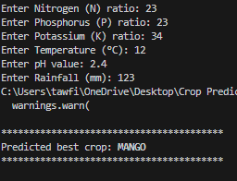
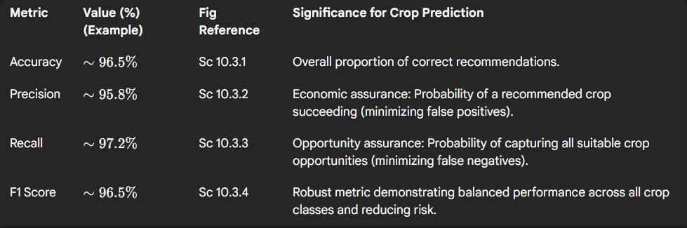

CHAPTER 11 CONCLUSIONS AND FUTURE SCOPE

The project successfully developed and deployed a highly accurate Crop Guidance System founded on the Random Forest Classifier. The system utilizes seven specific environmental and soil parameters (N, P, K, Temperature, Humidity, pH, and Rainfall) to prescribe the optimal crop label. Validation using classification metrics, specifically the high F1-Scores achieved, confirms the model's robustness and capability to handle the inherent non-linearity and heterogeneity of the agricultural feature space. The structural integration of the ML model into a lightweight, deployable web architecture (utilizing Flask and Sqlite3) ensures both user accessibility and efficient resource utilization. The chosen methodology provides an optimized solution for static, condition-based classification, delivering actionable agricultural prescriptions with high confidence

Future Scope
Future studies can expand the system’s utility by transitioning from single-step classification to multi-step prediction. This transition involves forecasting variables like optimal resource allocation or predicted yield over an entire growing season, which necessitates exploring advanced time-series models such as LSTM and GRU. The future development roadmap, which requires knowledge of sequential modeling, aligns with the theoretical background provided earlier in the report. To improve predictive accuracy, future iterations should focus on real-time feature integration by integrating external APIs (weather data, satellite imagery, or direct soil sensor outputs). This move would replace the current reliance on manual input (Sc 10.3.11) and enhance the system’s dynamism. Additionally, performance can be optimized through rigorous hyper- parameter tuning using advanced search techniques (e.g., Bayesian optimization). Finally, future work should include the development of a dedicated mobile application to facilitate ease of use for agricultural workers in the field and the inclusion of sustainability reporting modules that quantify the predicted reduction in water and fertilizer usage resulting from optimized crop selection.

CHAPTER 12 REFERENCES
[1].Ersin Elbasi, Chamseddine Zaki, Ahmet E. Topcu, Wiem Abdelbaki, Aymen I., ‘‘Comparative analysis of ML algorithms (Naïve Bayes, LR, RF) using NPK and climate data. https://www.mdpi.com/2076-3417/13/16/9288

[2].“Research on crop recommendation achieving high accuracy using a Random Forest model.” Praveen Kumar Maduri, Preeti Dhiman, Rishabh Srivastava
https://www.researchgate.net/publication/382318196_CROP_RECOMMENDATION_SYSTEM_U SING_MACHINE_LEARNING

[3].“Crop management using an ensemble learning approach with IoT sensor data”. Pedina Kira Available: https://www.mdpi.com/2673-4591/67/1/51

[4].“Technical implementation outlining a crop recommendation system with NPK, climate, and pH inputs.” Aarthi S, Manimegalai S, and Sakthivel R. [Online]. Available: https://www.kaggle.com/code/patelris/crop-prediction-analysis-w-classification

[5].Study titled "Intelligent Crop Recommendation System using Machine Learning" (ICCMC 2021). Priyadharshini

[6].Review paper on ML techniques for soil classification and crop suitability assessment.
Murali Krishna Senapaty, Abhishek Ray, and Neelamadhab Padhy

[7].Comparative study finding k-NN superior for crop prediction based on seasonal and soil parameters Patel and Patel (2021)

[8].Paper detailing an AI-powered crop recommendation system using an ensemble of ML algorithms. Hadeeqa Afzal, Madiha Amjad, Ali Raza, Kashif Munir, Santos Gracia Villar, Luis Alonso Dzul Lopez, and Imran Ashraf

